Executive Principal’s Blog

Welcome to my second blog, marking the end of an incredibly busy term for students and staff.

I am pleased to say our young people have settled well after their moves between sites at the start of the term, allowing Key Stage students to be taught at Phoenix House, Key Stage 3 students and Key Stage 4 students being taught at Sevenhills and Park House retrospectively.

Thank you to everybody for their support and cooperation to ensure the changes ran smoothly. Students have embraced the moves and positive relationships have been formed between them and staff.
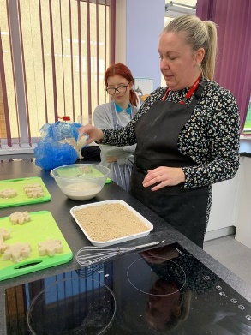
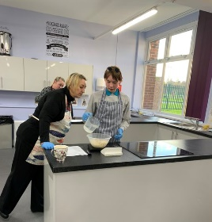
Careers have come into focus at Park House Academy with Iceland Seafoods’ New Product Design team coming in to support learners and talk about career opportunities within their industry.

This gave students an insight into their working lives and the careers offered by the company, sometimes starting on the factory floor and progressing into management roles.

The team’s advice was well received by students and we thank them for coming in.

We have had students take part in a variety of work experience opportunities. These have included placements at Nunny Farm, Exotics of the World pet shop, and with a construction company on a building site; these opportunities have allowed students to put into practice what they have learnt in the classroom

Positive feedback has been received about the students and our thanks to those who offered a chance to learn more about the world of work.

Our huge push with the new reading strategy has continued across our three sites. I’m delighted that students have read more than 654,000 words this term collectively, a tremendous effort. Let’s keep it up!
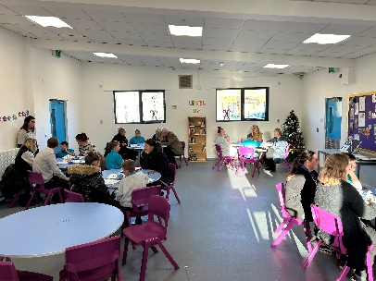
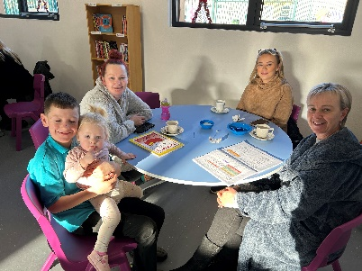
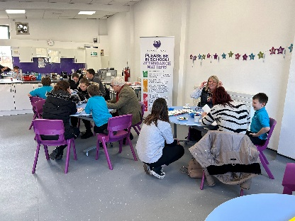

Phoenix House held a popular reading afternoon, with parents/carers and stakeholders invited to join the students.

It was great to hear some of the feedback. One parent could not believe how much their child had done while at the Academy, compared to previous schools.

A music workshop has been held at Park House throughout the term, with the plan to perform during the Year 11 leavers’ ceremony. I shall look forward to hearing their efforts.
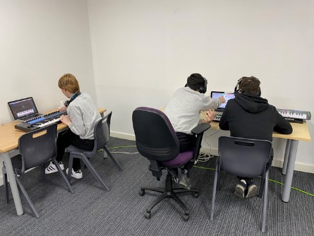
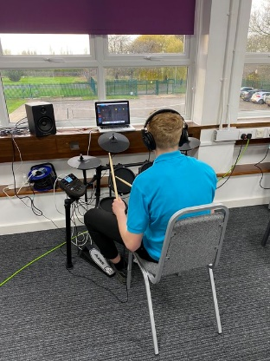

Each half term students focus on a different country to learn about its culture and cuisine.

These last few weeks we have been looking at Qatar, coinciding with it hosting the football World Cup. Students enjoyed cooking a chicken and rice dish and the work has been well received.

Our thanks to Nina Stobart at Phillips 66 for their generous support which has ensured each of our families across the three sites are being sent a Christmas hamper.

On that note, on behalf of the staff team, I would like to wish everybody a merry Christmas and a happy, healthy and safe New Year.

Phil Hutchinson
Executive Principal

