17th November, 2022

Phoenix Park and Sevenhills Academy Blog

Welcome to the first of a half termly new blog.

It adds to the ways we communicate with our parents/carers, students and wider academy communities across our three Grimsby sites.

It will celebrate the achievements of our students and recognise the considerable efforts of our staff.

I hope you enjoy reading it and find it a useful source of information, while not taking too much time out of busy lives.

Our sites have experienced positive impacts on reading following the launch of a new strategy, Reading Plus.
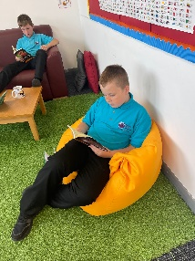
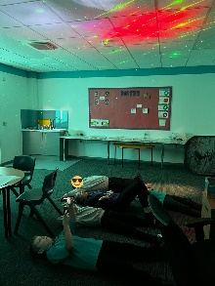
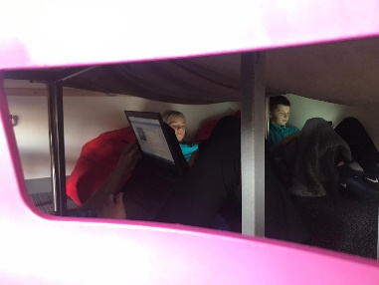

Sevenhills Academy students have read almost 339, 000 words so far this term, its success is evidenced by higher numbers of students showing progress in academic achievement and SEMH
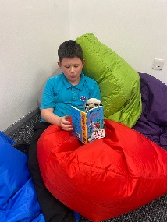
Students at Phoenix House have read 125,845 words and are demonstrating a greater willingness to pick up a book and read for pleasure.

The strategies are also having a big impact at Park, students have read 422,688 words; with a number of students taking books home to read.

Let’s maintain those improvements!
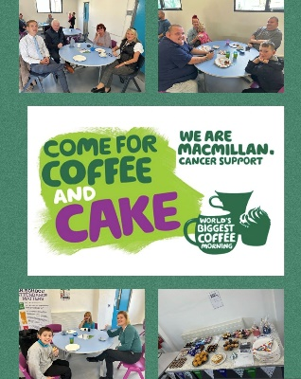
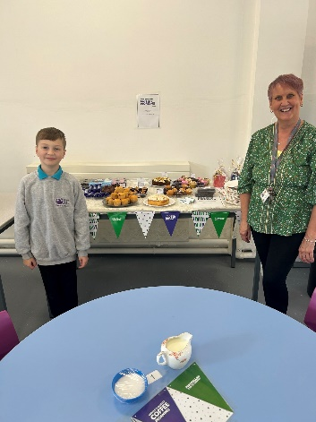
All three sites hosted coffee mornings for MacMillan Cancer Support, raising almost £450.

Thank you to those who contributed to making them a success, including the parents /carers who came along to support.

A pupil referral unit from Hull was invited to play football at Sevenhills.
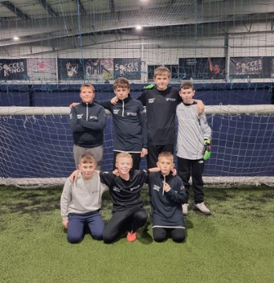
Two mixed teams from the Sevenhills Academy plus another one from Park House were invited to a return fixture, taking part in a mini, indoor tournament with two sides from Hull.

The event was a huge success and much enjoyed by the students. The emphasis was on the importance of participating - demonstrating togetherness and teamwork - rather than winning.

At Phoenix House, some students have been taking part in Forest School activities on Wednesday and Thursday afternoons.

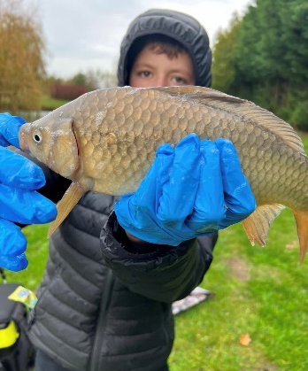
They’ve enjoyed being outdoors, building fires and cooking food among the activities.

They have also shown great teamwork and communication skills, engaging with their peers and staUpdated Au2ff in a different learning environment.

Park’s Forest School activities have included fishing, hiking and building shelters, which proved hugely successful.

DJ workshops have been taking place at Park House. Students have been learning how to operate the decks, whilst some have been using a keyboard and others have even been writing their own lyrics.

Thank you for reading the blog – the next one will be published just before the Christmas holidays.

Phil Hutchinson
Executive Principal

