Yellow class have been making alien slime in Topic to help them think of how aliens might look. This helped them create a character description in Literacy. They also was able to write a recount of how they made the slime.

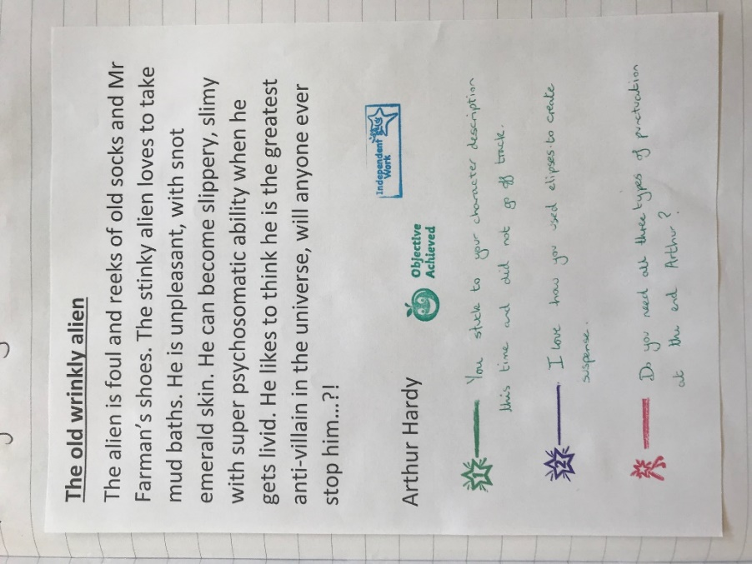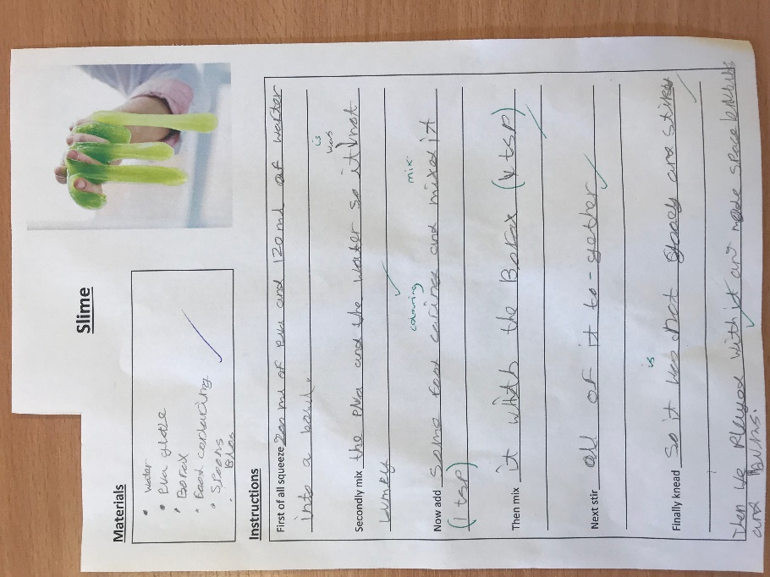

They also enjoyed using their measuring skills learnt in Numeracy to measure how much PVA glue and water to use and was able to follow simple instructions.
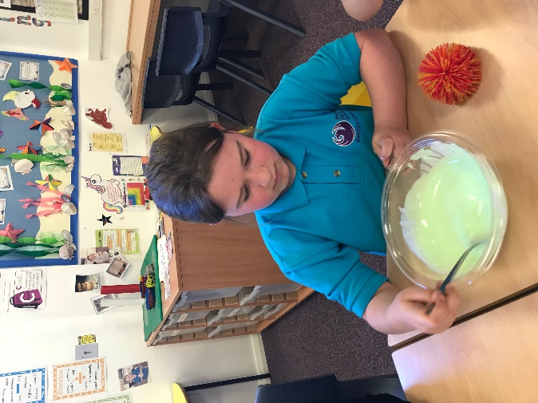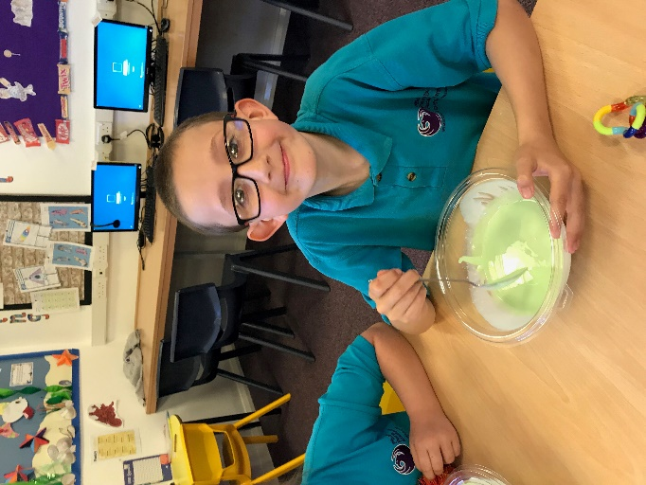
After making the slime they loved playing with it and making space bubbles. They found this very therapeutic.

